
CIDM 6350 Project
Online Food Ordering System

March 6, 2026
Tiwa shadare

Contents
Section 1 2
Introduction 2
A. Chosen Area 2
B. Data Management Problems 2
C. Motivation for the Database 3
D. Potential Benefits 3
E. Potential Users 3
Section 2 4
1. Core Business Activities 4
2. Entities, Attributes, and Data Types 4
2.1. Customer Entity 4
2.2. Restaurant Entity 4
2.3. Menu Entity 5
2.4. Order Entity 6
2.5. Payment Entity 6
2.6. Driver Entity 7
2.7. Delivery Entity 7
3. User Requirements 8
Section 3 8
Section 4 10
Section 5 11
Sections 6 & 7 17

Section 1

Introduction
The chosen area for this project is the online food ordering and delivery industry. This database is designed to manage customers, restaurants, menu items, orders, payments, and delivery operations within a centralized relational database system.
With the rapid growth of digital platforms, efficient and accurate data management has become essential. These platforms process thousands of daily transactions involving multiple interacting entities. Without a structured database system, managing such high-volume operations would lead to errors, inefficiencies, and financial losses. This project proposes a relational database solution that ensures data integrity, minimizes redundancy, enforces business rules, and supports efficient querying.
- Chosen Area
This industry involves interactions among customers, restaurants, delivery drivers, and payment systems. Data that must be managed includes:
- Customer profiles
- Menu items and pricing
- Orders and order details
- Payments
- Delivery
Because these components are highly interrelated, the online food ordering environment is well suited for a relational database management system (RDBMS).
- Data Management Problems
Data mismanagement in this industry can result in serious operational and financial consequences. Common issues include:
- Data Redundancy and Inconsistency: Storing duplicate customer or menu data can cause inconsistent pricing, multiple customer records, and inaccurate order histories.
- Lack of Data Integrity: Without enforced relationships, orders may exist without valid customers, payments may not match orders, and delivery assignments may reference non-existent drivers.
- Inefficient Reporting and Decision-Making: Unstructured or poorly organized data makes it difficult to generate accurate reports, track revenue, analyze customer trends, or monitor restaurant performance.
- Limited Scalability: As transaction volume increases, poorly designed systems may experience data duplication, transaction loss, or performance degradation.

- Motivation for the Database
The motivation for developing this database is to address these problems using core relational database principles:
- Data Integrity: Primary and foreign keys enforce valid relationships between customers, orders, payments, and deliveries.
- Reduced Redundancy: Normalization to Third Normal Form (3NF) ensures that data is stored efficiently without unnecessary duplication.
- Referential Integrity: Orders cannot exist without valid customers, and payments cannot exist without corresponding orders.
- Efficient Query Processing: Structured tables enable fast retrieval of order history, revenue summaries, and performance analytics.
By aligning database design principles with industry needs, this system provides a reliable and scalable data management solution.
- Potential Benefits
Implementing this Online Food Ordering System database provides several advantages:
- Accurate Order Processing: Eliminates mismatches between orders and payments.
- Real-Time Data Consistency: Ensures up-to-date menu availability and delivery status.
- Improved Customer Experience: Reduces billing errors and delivery confusion.
- Financial Transparency: Enables accurate revenue tracking and performance reporting.
- Better Decision-Making: SQL queries and multi-table joins allow analysis of sales trends, popular menu items, and delivery performance.
These benefits directly reduce the operational risks described earlier and enhance overall efficiency.
- Potential Users
The database will support multiple user groups:
- Customers: Place orders, view history, and track deliveries while avoiding duplicate accounts and billing errors.
- Restaurant Managers: Manage menus, monitor orders, and track revenue, reducing pricing inconsistencies and data inaccuracies.
- Delivery Drivers: Access assigned deliveries and update order status, preventing delivery mismatches.
- System Administrators: Maintain database integrity, enforce constraints, and generate analytical reports.
- Business Owners/Executives: Analyze performance metrics and sales trends to support strategic decision-making.

Section 2
Below are the detailed business rules and user requirements that must guide the database design.

Core Business Activities
The business platform allows:
- Customers to register and create accounts
- Restaurants to register and list menus
- Customers to place orders from restaurants
- Customers to pay for their orders
- Delivery drivers to deliver orders
- Customers to leave reviews
The database must support all these interactions through structured relationships.

Entities, Attributes, and Data Types
Below are the required entities with their attributes and expected data types

Customer Entity
Entity Name: Customer
Attributes:
- Customer_ID (INT, Primary Key)
- First_Name (VARCHAR(50), NOT NULL)
- Last_Name (VARCHAR(50), NOT NULL)
- Email (VARCHAR(100), UNIQUE, NOT NULL)
- Phone_Number (VARCHAR(15), NOT NULL)
- Street_Address (VARCHAR(150), NOT NULL)
- City (VARCHAR(50), NOT NULL)
- State (VARCHAR(50), NOT NULL)
- Zip_Code (VARCHAR(10), NOT NULL)
- Date_Registered (DATETIME, NOT NULL)
Business Rules:
- A customer must have a unique email address.
- A customer can place zero or many orders.
Cardinality:
Customer (1) — (0:M) Order

Restaurant Entity
Entity Name: Restaurant
Attributes:
- Restaurant_ID (INT, Primary Key)
- Restaurant_Name (VARCHAR(100), NOT NULL)
- Phone_Number (VARCHAR(15), NOT NULL)
- Street_Address (VARCHAR(150), NOT NULL)
- City (VARCHAR(50), NOT NULL)
- State (VARCHAR(50), NOT NULL)
- Zip_Code (VARCHAR(10), NOT NULL)
- Cuisine_Type (VARCHAR(50), NOT NULL)
- Rating (DECIMAL(2,1))
- ManagerID (INT, Foreign Key)
Business Rules:
- A restaurant can have many menu items.
- A restaurant can receive zero to many orders.
- A restaurant may refer other restaurants.
Cardinality:
Restaurant (1) — (1:M) Menu
Restaurant (1) — (0:M) Order

Menu Entity
Entity Name: Menu
Attributes:
- Menu_Item_ID (INT, Primary Key)
- Restaurant_ID (INT, Foreign Key)
- Item_Name (VARCHAR(100), NOT NULL)
- Description (VARCHAR(255))
- Price (DECIMAL(8,2), NOT NULL)
- Availability_Status (VARCHAR(20))
Business Rules:
- Each menu item must belong to one restaurant.
- A menu item can appear in many order items.
- Price must be greater than zero.
Cardinality:
Restaurant (1) — (1:M) Menu
Menu (1) — (1:M) Order

Order Entity
Entity Name: Order
Attributes:
- Order_ID (INT, Primary Key)
- Customer_ID (INT, Foreign Key)
- Restaurant_ID (INT, Foreign Key)
- Order_Date (DATETIME, NOT NULL)
- Order_Status (VARCHAR(30), NOT NULL)
- Total_Amount (DECIMAL(10,2), NOT NULL)
Business Rules:
- An order must belong to exactly one customer.
- An order must belong to exactly one restaurant.
- An order must contain at least one menu item.
- Order total must equal the sum of its order items.
Cardinality:
Customer (1) — (0:M) Order
Restaurant (1) — (0:M) Order
Order (1) — (1:1) Payment
Order (1) — (0:1) Delivery

Payment Entity
Entity Name: Payment
Attributes
- Payment_ID (INT, Primary Key)
- Order_ID (INT, Foreign Key)
- Payment_Date (DATETIME, NOT NULL)
- Payment_Method (VARCHAR(50), NOT NULL)
- Payment_Status (VARCHAR(30), NOT NULL)
- Amount_Paid (DECIMAL(10,2), NOT NULL)
Business Rules:
- Each payment must correspond to exactly one order.
- Each order must have exactly one payment.
- Amount paid must equal order total.
Cardinality:
Order (1) —— (1:1) Payment

Driver Entity
Entity Name: Driver
Attributes:
- Driver_ID (INT, Primary Key)
- First_Name (VARCHAR(50), NOT NULL)
- Last_Name (VARCHAR(50), NOT NULL)
- Phone_Number (VARCHAR(15), NOT NULL)
- Vehicle_Type (VARCHAR(50))
- Availability_Status (VARCHAR(20))
Business Rules:
- A driver can perform many deliveries.
- Delivery of an order can involve at most one driver.
Cardinality:
Driver (1) — (0:M) Delivery

Delivery Entity
Entity Name: Delivery
Attributes:
- Delivery_ID (INT, Primary Key)
- Order_ID (INT, Foreign Key)
- Driver_ID (INT, Foreign Key)
- Restaurant_ID (INT, Foreign Key)
- Delivery_Status (VARCHAR(30), NOT NULL)
- Pickup_Time (DATETIME)
- Delivery_Time (DATETIME)
Business Rules:
- Each delivery must belong to one order.
- A delivery must be assigned to one driver.
- Not all orders require delivery (pickup option).
Cardinality:
Order (1) —— (0:1) Delivery
Driver (1) —— (0:M) Delivery

User Requirements
The system must allow users to:
Customers
- Register and log in
- Browse restaurants and menu items
- Place and pay for orders
- View order history
Restaurants
- Add, update, and remove menu items
- View incoming orders
- Update order status
Drivers
- View assigned deliveries
- Update delivery status

Section 3
The Enhanced Entity Relationship Diagram (EERD) for the Online Food Ordering System illustrates the structure and relationships between the key entities involved in the platform’s operations. At the top of the diagram, User serves as a supertype that contains general attributes such as UserID, name, email, and phone number. It is specialized into three disjoint subtypes: Customer, Driver, and Restaurant_Manager, each with role-specific attributes. Customers place Orders, which include details such as order date, status, and total amount, and each order is associated with a specific Restaurant. Restaurants maintain Menu items that include item names, descriptions, pricing, and availability. Orders are processed through a Payment entity that records payment details such as method, date, and amount paid. Deliveries are handled through the Delivery entity, which links orders with drivers and restaurants while tracking delivery status and timing.
Additionally, the diagram includes a unary relationship where a Restaurant can refer another restaurant to the platform. Overall, the diagram demonstrates how users, restaurants, orders, payments, menus, and deliveries interact within a structured relational database design.
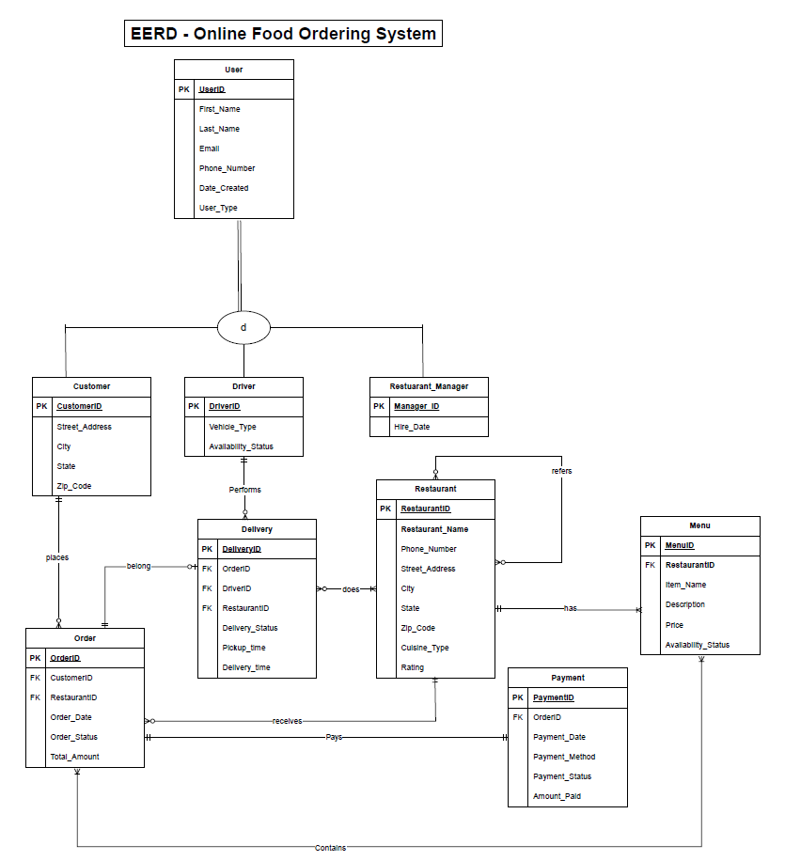

Section 4
Relations Diagram
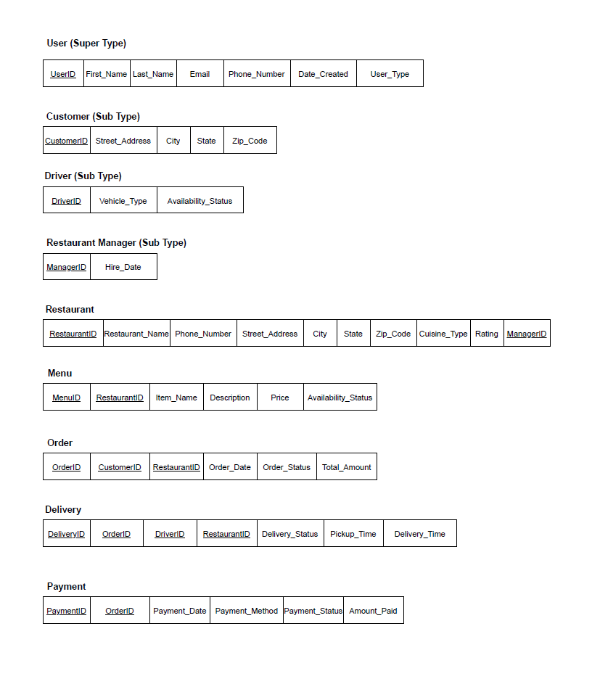

Section 5
Create Database
CREATE DATABASE OnlineFoodOrderingDB;
USE OnlineFoodOrderingDB;

Create User Table
CREATE TABLE USER
(
UserID INTEGER NOT NULL,
First_Name VARCHAR(25),
Last_Name VARCHAR(25),
Email VARCHAR(50),
Phone_Number VARCHAR(15),
Date_Created DATE,
User_Type VARCHAR(20),
CONSTRAINT USER_PK PRIMARY KEY (UserID)
);
Create Customer Table
CREATE TABLE CUSTOMER
(
CustomerID INTEGER NOT NULL,
Street_Address VARCHAR(50),
City VARCHAR(25),
State VARCHAR(2),
Zip_Code VARCHAR(10),
CONSTRAINT CUSTOMER_PK PRIMARY KEY (CustomerID),
CONSTRAINT CUSTOMER_FK1 FOREIGN KEY (CustomerID)
REFERENCES USER(UserID)
);
Create Driver Table
CREATE TABLE DRIVER
(
DriverID INTEGER NOT NULL,
Vehicle_Type VARCHAR(25),
Availability_Status VARCHAR(20),
CONSTRAINT DRIVER_PK PRIMARY KEY (DriverID),
CONSTRAINT DRIVER_FK1 FOREIGN KEY (DriverID)
REFERENCES USER(UserID)
);
Create Restaurant Manager Table
CREATE TABLE RESTAURANT_MANAGER
(
ManagerID INTEGER NOT NULL,
Hire_Date DATE,
CONSTRAINT MANAGER_PK PRIMARY KEY (ManagerID),
CONSTRAINT MANAGER_FK1 FOREIGN KEY (ManagerID)
REFERENCES USER(UserID)
);
Create Restaurant Table
CREATE TABLE RESTAURANT
(
RestaurantID INTEGER NOT NULL,
Restaurant_Name VARCHAR(50),
Phone_Number VARCHAR(15),
Street_Address VARCHAR(50),
City VARCHAR(25),
State VARCHAR(2),
Zip_Code VARCHAR(10),
Cuisine_Type VARCHAR(25),
Rating DECIMAL(2,1),
ManagerID INTEGER,
CONSTRAINT RESTAURANT_PK PRIMARY KEY (RestaurantID),
CONSTRAINT RESTAURANT_FK1 FOREIGN KEY (ManagerID)
REFERENCES RESTAURANT_MANAGER(ManagerID)
);
Create Menu Table
CREATE TABLE MENU
(
MenuID INTEGER NOT NULL,
RestaurantID INTEGER,
Item_Name VARCHAR(50),
Description VARCHAR(100),
Price DECIMAL(6,2),
Availability_Status VARCHAR(20),
CONSTRAINT MENU_PK PRIMARY KEY (MenuID),
CONSTRAINT MENU_FK1 FOREIGN KEY (RestaurantID)
REFERENCES RESTAURANT(RestaurantID)
);

Create Orders Table
CREATE TABLE ORDERS
(
OrderID INTEGER NOT NULL,
CustomerID INTEGER,
RestaurantID INTEGER,
Order_Date DATE,
Order_Status VARCHAR(20),
Total_Amount DECIMAL(8,2),
CONSTRAINT ORDERS_PK PRIMARY KEY (OrderID),
CONSTRAINT ORDERS_FK1 FOREIGN KEY (CustomerID)
REFERENCES CUSTOMER(CustomerID),
CONSTRAINT ORDERS_FK2 FOREIGN KEY (RestaurantID)
REFERENCES RESTAURANT(RestaurantID)
);
Create Delivery Table
CREATE TABLE DELIVERY
(
DeliveryID INTEGER NOT NULL,
OrderID INTEGER,
DriverID INTEGER,
RestaurantID INTEGER,
Delivery_Status VARCHAR(20),
Pickup_Time DATETIME,
Delivery_Time DATETIME,
CONSTRAINT DELIVERY_PK PRIMARY KEY (DeliveryID),
CONSTRAINT DELIVERY_FK1 FOREIGN KEY (OrderID)
REFERENCES ORDERS(OrderID),
CONSTRAINT DELIVERY_FK2 FOREIGN KEY (DriverID)
REFERENCES DRIVER(DriverID),
CONSTRAINT DELIVERY_FK3 FOREIGN KEY (RestaurantID)
REFERENCES RESTAURANT(RestaurantID)
);
Create Payment Table
CREATE TABLE PAYMENT
(
PaymentID INTEGER NOT NULL,
OrderID INTEGER,
Payment_Date DATE,
Payment_Method VARCHAR(20),
Payment_Status VARCHAR(20),
Amount_Paid DECIMAL(8,2),
CONSTRAINT PAYMENT_PK PRIMARY KEY (PaymentID),
CONSTRAINT PAYMENT_FK1 FOREIGN KEY (OrderID)
REFERENCES ORDERS(OrderID)
);
Insert Queries
Insert into User table
INSERT INTO USER VALUES (1,'John','Doe','johndoe@gmail.com','111-2345','2025-12-31','Customer');
INSERT INTO USER VALUES (2,'Jane','Smith','janesmith@hotmail.com','222-3456','2026-01-02','Customer');
INSERT INTO USER VALUES (3,'Mike','Brown','mikeb@aol.com','333-4567', '2026-01-04','Driver');
INSERT INTO USER VALUES (4,'Sara','White','sarawhite@yahoo.com','444-5678', '2026-01-09','Driver');
INSERT INTO USER VALUES (5,'Tom','Harris','tharris@yahoo.com','555-6789', '2026-01-01','Manager');
INSERT INTO USER VALUES (6,'Lucy','Green','lucygreen@hotmail.com','657-8901','2026-01-01','Manager');
INSERT INTO USER VALUES (7,'Chris','Black','chrisb@gmail.com','789-0123', '2026-01-15','Customer');
INSERT INTO USER VALUES (8,'Emma','Stone','emmas@aol.com','891-1234', '2026-01-26','Customer');
INSERT INTO USER VALUES (9,'Noah','King','noahking@mailinator.com','989-0789', '2026-01-28','Driver');
INSERT INTO USER VALUES (10,'Liam','Scott','liams@gmail.com','121-1589', '2026-01-18','Customer');
Insert into Customer table
INSERT INTO CUSTOMER VALUES (1,'123 Main St','Dallas','TX','75001');
INSERT INTO CUSTOMER VALUES (2,'456 Oak St','Denton','TX','76201');
INSERT INTO CUSTOMER VALUES (7,'789 Pine St','Plano','TX','75074');
INSERT INTO CUSTOMER VALUES (8,'321 Elm St','Frisco','TX','75033');
INSERT INTO CUSTOMER VALUES (10,'654 Cedar St','Allen','TX','75002');
Insert into Driver table
INSERT INTO DRIVER VALUES (3, 'SUV', 'Available');
INSERT INTO DRIVER VALUES (4,'Sedan','Busy');
INSERT INTO DRIVER VALUES (9,'Motorcycle','Available');

Insert into Restaurant Manager table
INSERT INTO RESTAURANT_MANAGER VALUES (5, '2026-01-01');
INSERT INTO RESTAURANT_MANAGER VALUES (6, '2026-01-01');
Insert into Restaurant table
INSERT INTO RESTAURANT VALUES (101, 'Tasty Grill', '555-1212', '500 Market St', 'Dallas', 'TX', '75001', 'American', '4.2',5);
INSERT INTO RESTAURANT VALUES (102, 'Pasta Palace', '555-1313', '200 Olive Rd', 'Plano', 'TX', '75074', 'Italian', 5,6);
INSERT INTO RESTAURANT VALUES (103, 'Sushi World', '555-1414', '300 Ocean Ave', 'Frisco', 'TX', '75034', 'Japanese', '4.8',6);
INSERT INTO RESTAURANT VALUES (104, 'Curry House', '555-1515', '400 Spice St', 'McKinney', 'TX', '75070', 'Indian', '4.5',5);
Insert into Menu table
INSERT INTO MENU VALUES (1001, 101, 'Burger', 'Beef burger with fries', 9.99, 'AVAILABLE');
INSERT INTO MENU VALUES (1002, 101, 'Chicken Sandwich', 'Grilled chicken sandwich', 8.49, 'AVAILABLE');
INSERT INTO MENU VALUES (1003, 102, 'Spaghetti', 'Classic spaghetti marinara', 12.99, 'AVAILABLE');
INSERT INTO MENU VALUES (1004, 102, 'Lasagna', 'Cheesy beef lasagna', 14.49, 'AVAILABLE');
INSERT INTO MENU VALUES (1005, 103, 'California Roll', 'Crab and avocado roll', 7.99, 'AVAILABLE');
INSERT INTO MENU VALUES (1006, 103, 'Salmon Nigiri', 'Fresh salmon over rice', 5.99, 'AVAILABLE');
INSERT INTO MENU VALUES (1007, 104, 'Chicken Tikka', 'Spiced grilled chicken', 11.99, 'AVAILABLE');
INSERT INTO MENU VALUES (1008, 104, 'Naan Bread', 'Fresh baked naan', 2.99, 'AVAILABLE');
Insert into Order table
INSERT INTO ORDERS VALUES (5001, 1, 101, '2026-04-19', 'PLACED', '18.48');
INSERT INTO ORDERS VALUES (5002, 2, 102, '2026-04-01', 'DELIVERED', '12.99');
INSERT INTO ORDERS VALUES (5003, 7, 103, '2026-04-15', 'DELIVERED', '13.98');
INSERT INTO ORDERS VALUES (5004, 8, 104, '2026-04-19', 'PLACED', '14.98');
INSERT INTO ORDERS VALUES (5005, 10, 101, '2026-04-10', 'CANCELLED', '0.00');
INSERT INTO ORDERS VALUES (5006, 1, 102, '2026-04-12', 'DELIVERED', '27.48');
INSERT INTO ORDERS VALUES (5007, 2, 103, '2026-04-05', 'PLACED', '7.99');
INSERT INTO ORDERS VALUES (5008, 7, 104, '2026-04-16', 'DELIVERED', '11.99');
Insert into Delivery table
INSERT INTO DELIVERY VALUES (9001, 5001, 3, 101, 'ON THE WAY', '2026-04-20 10:15:00', NULL);
INSERT INTO DELIVERY VALUES (9002, 5002, 4, 102, 'DELIVERED', '2026-04-18 09:05:22', '2026-04-18 09:30:36');
INSERT INTO DELIVERY VALUES (9003, 5003, 4, 103, 'DELIVERED', '2026-04-17 20:10:10', '2026-04-17 20:41:05');
INSERT INTO DELIVERY VALUES (9004, 5004, 9, 104, 'PICKED UP', '2026-04-20 11:25:00', NULL);
INSERT INTO DELIVERY VALUES (9005, 5006, 3, 102, 'DELIVERED', '2026-04-15 18:22:11', '2026-04-15 18:56:04');
INSERT INTO DELIVERY VALUES (9006, 5008, 9, 104, 'DELIVERED', '2026-04-13 16:40:29', '2026-04-13 17:00:29');
Insert into Payment table
INSERT INTO PAYMENT VALUES (7001, 5001, '2026-04-20', 'CARD', 'PAID', 18.48);
INSERT INTO PAYMENT VALUES (7002, 5002, '2026-04-19', 'CASH', 'PAID', 12.99);
INSERT INTO PAYMENT VALUES (7003, 5003, '2026-04-18', 'CARD', 'PAID', 13.98);
INSERT INTO PAYMENT VALUES (7004, 5004, '2026-04-20', 'CARD', 'PENDING', 14.98);
INSERT INTO PAYMENT VALUES (7005, 5006, '2026-04-17', 'CARD', 'PAID', 27.48);
INSERT INTO PAYMENT VALUES (7006, 5008, '2026-04-16', 'CASH', 'PAID', 11.99);

Sections 6 & 7
Queries
  - Single table lookup - View registered users and contact info
SELECT USERID, CONCAT(First_Name, ' ', Last_Name) AS Full_Name, Email, phone_number, date_created
FROM user
ORDER BY Date_created DESC;
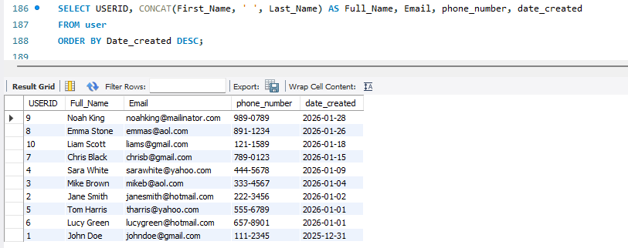

  - Single table lookup – View available menu items
SELECT MenuID, Item_Name, Price, Availability_status
FROM Menu
WHERE Availability_status = ‘AVAILABLE’
ORDER BY Price DESC;
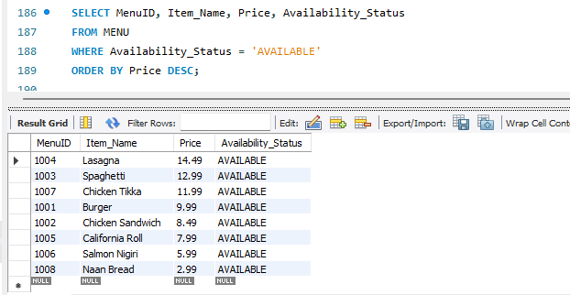
  - Join Query – View orders placed by customers.
SELECT o.OrderId, CONCAT(u.First_Name, ' ', u.Last_Name) AS Customer_Name, r.Restaurant_Name, o.Order_Date, o.Order_Status, o.Total_Amount
FROM ORDERS o
JOIN CUSTOMER c ON o.CustomerId = c.CustomerId
JOIN USER u ON c.CustomerId = u.UserId
JOIN RESTAURANT r ON o.RestaurantId = r.RestaurantId
ORDER BY o.OrderId;
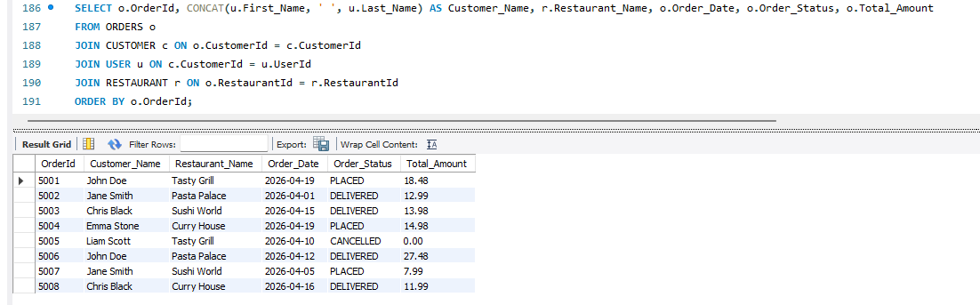
  - Join Query – View Payment Status of Orders
SELECT o.OrderID, p.Payment_Method, p.Payment_Status, p.Amount_Paid
FROM Orders o
JOIN Payment p ON o.OrderID = p.OrderID
ORDER BY p.Payment_Status;
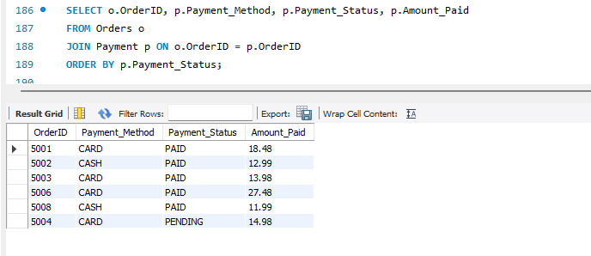
  - Join Query – Track Drivers and their delivery status
SELECT d.DriverId, CONCAT(u.First_Name, ' ', u.Last_Name) AS DriverName, de.DeliveryId,
de.Delivery_Status, de.Pickup_Time, de.Delivery_Time
FROM DELIVERY de
JOIN DRIVER d ON de.DriverId = d.DriverId
JOIN USER u ON d.DriverId = u.UserId
ORDER BY d.DriverId, de.DeliveryId;
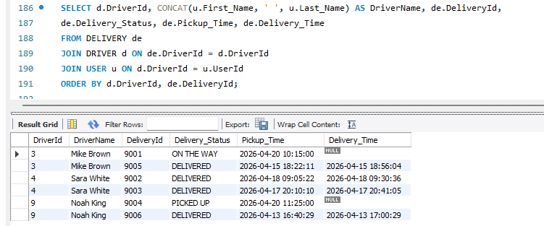
  - Join Query – Track Restaurant’s revenue
SELECT r.Restaurant_Name, SUM(o.Total_Amount) AS Total_Revenue
FROM ORDERS o
JOIN RESTAURANT r ON o.RestaurantId = r.RestaurantId
WHERE o.Order_Status <> 'CANCELLED'
GROUP BY r.Restaurant_Name
ORDER BY Total_Revenue DESC;
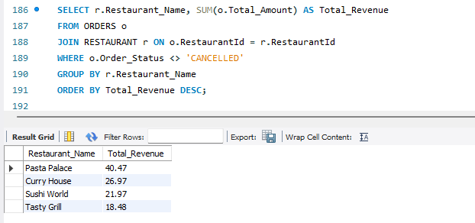
  - Join Query – Total orders per customer where total order is equal or greater than 2
SELECT CONCAT(u.First_Name, ' ', u.Last_Name) AS Customer_Name, COUNT(o.OrderId) AS Total_Orders
FROM ORDERS o
JOIN CUSTOMER c ON o.CustomerId = c.CustomerId
JOIN USER u ON c.CustomerId = u.UserId
GROUP BY u.First_Name, u.Last_Name
HAVING COUNT(o.OrderId) >= 2
ORDER BY Total_Orders DESC;
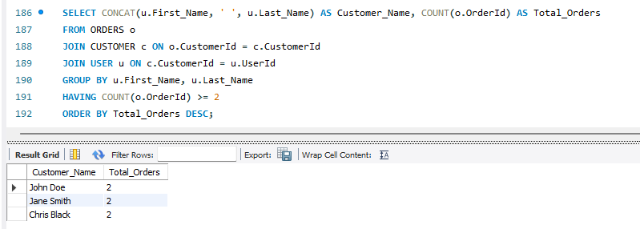
  - Subquery – Customers who spent above average
SELECT CONCAT(u.First_Name, ' ', u.Last_Name) AS CustomerName, o.Total_Amount
FROM ORDERS o
JOIN CUSTOMER c ON o.CustomerId = c.CustomerId
JOIN USER u ON c.CustomerId = u.UserId
WHERE o.Total_Amount > (
SELECT AVG(Total_Amount) FROM ORDERS
);
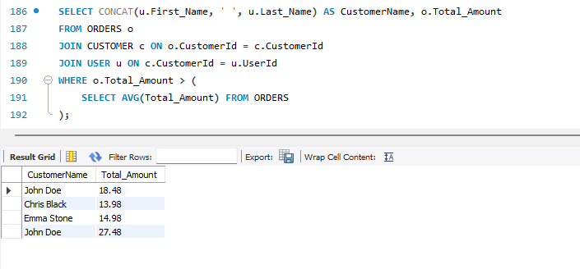

  - Subquery – Most Expensive Item per restaurant
SELECT r.Restaurant_Name, m.Item_Name, m.Price
FROM Menu m
JOIN Restaurant r ON m.RestaurantID = r.RestaurantID
WHERE m.Price = (
SELECT MAX(m2.Price)
FROM Menu m2
WHERE m2.RestaurantID = m.RestaurantID
);
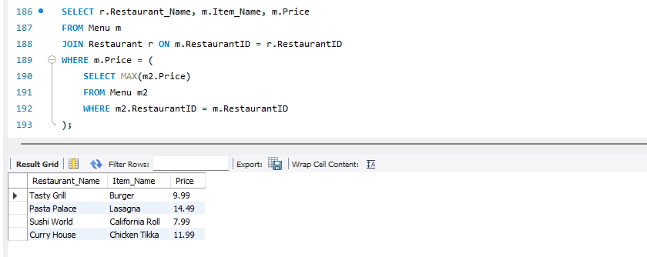
  - Subquery – Orders without delivery
SELECT o.OrderID, o.Order_Status
FROM ORDERS o
WHERE o.OrderID NOT IN (
SELECT d.OrderID FROM Delivery d
);
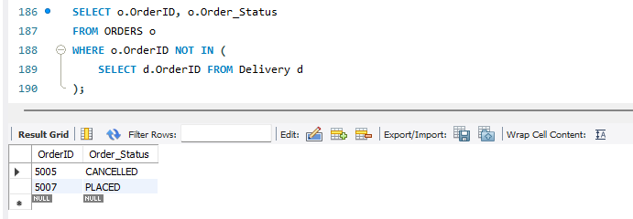

  - Store Procedure – Created a Store Procedure to get orders from a customer
DELIMITER $$

CREATE PROCEDURE GetCustomerOrder(IN custId INT)
BEGIN
SELECT o.OrderId, o.Order_Date, o.Order_Status, o.Total_Amount, r.Restaurant_Name
FROM ORDERS o
JOIN RESTAURANT r ON o.RestaurantId = r.RestaurantId
WHERE o.CustomerId = custId;
END $$
DELIMITER ;
CALL GetCustomerOrder(1);
